**COMSATS University Islamabad, Attock Campus**Department of Computer Science

Course: **Artificial intelligence lab**

Class: **BSCS 5**  Semester: **SP 2022**

**Guidelines:** Assignment #03

* You have to run the code of BFS algorithms 5 time
* Each time u have to pass different number of values to the list

1)20k 2)30k 3)50k 4) 80k 5)90k

🡪pass random values to list of given above ranges using random (import random)

Note: you have to search on Google (“how to create random list for specified range with random”)

* Calculate time for BFS algorithms by using “import time”

Note : search on Google how to get time in seconds

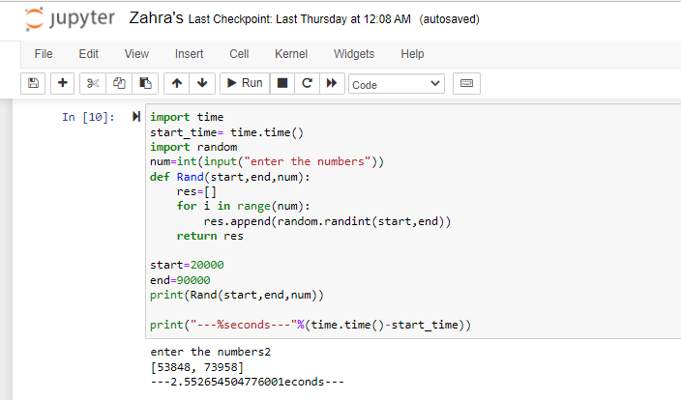

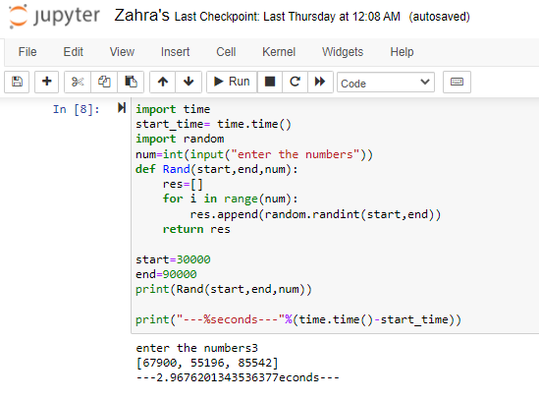

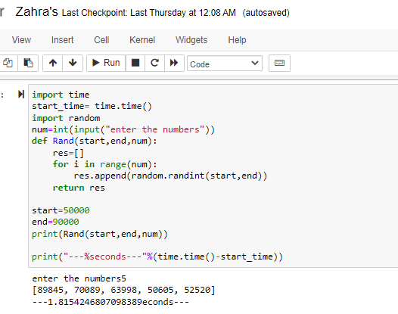

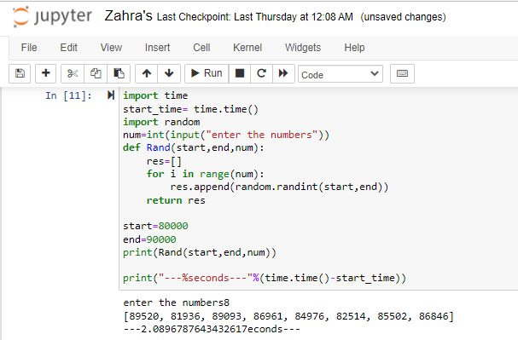

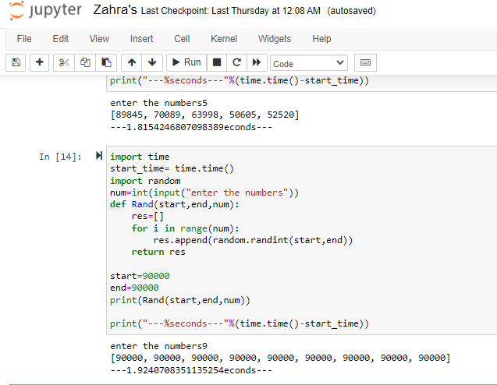

* Make a table and store your results after calculating time for each algorithms

|  |  |  |  |  |  |
| --- | --- | --- | --- | --- | --- |
| values | 20k | 30k | 50k | 80k | 90k |
| Time for BFS | 2.55264 sec | 2.967620  sec | 1.815424  sec | 2.08967  sec | 1.924070  sec |